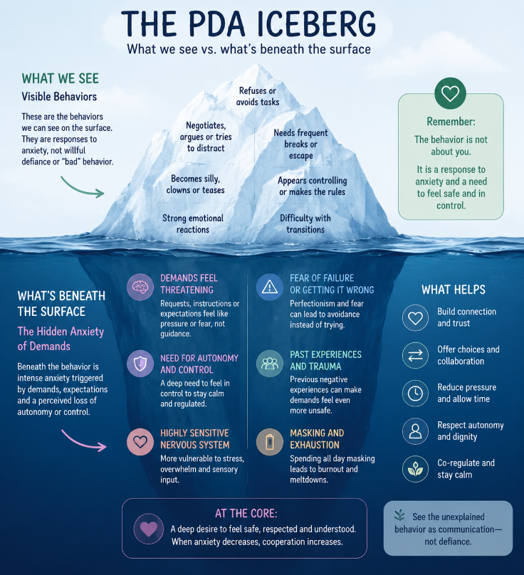
Understanding the PDA (Pathological Demand Avoidance) Profile in the Classroom

What is PDA?
Pathological Demand Avoidance (PDA) is a profile that some autistic individuals exhibit. Rather than simply disliking demands, students with a PDA profile experience an intense anxiety response when they feel their autonomy or sense of control is threatened.
This is not willful defiance, manipulation, or poor parenting. Their nervous system often interprets everyday expectations as overwhelming, causing a fight, flight, freeze, or fawn response.

A student with PDA may:
- Want to do well but seem unable to comply in the moment.
- Alternate between high capability and complete refusal.
- Be highly creative, intelligent, and socially aware.
- Use avoidance as a coping strategy for anxiety.

How PDA May Look in the Classroom
Instead of:
- "Won't do it"
Think:
- "Can't do it right now because their anxiety has taken over."
Common signs include:
- Refusing seemingly simple tasks.
- Negotiating, distracting, joking, or changing the subject.
- Needing frequent breaks.
- Becoming silly or clowning to avoid work.
- Appearing controlling or wanting to make the rules.
- Strong emotional reactions to correction.
- Perfectionism leading to avoidance.
- Masking throughout the day and melting down after school.
- Difficulty transitioning between activities.
- Increased challenges during times of stress, fatigue, illness, or sensory overload.

What Helps

Give Choices
Instead of:
"Do this now."
Try:
"Would you like to start with the first problem or the second?"
“Would you like to use a pencil or a marker?”

Reduce Direct Demands
Use collaborative language:
- "Let's figure this out together."
- "I wonder if..."
- "When you're ready..."
- "Could we try...?"

Preserve Dignity
Avoid public corrections, power struggles, or forcing compliance in front of peers.

Prioritize Relationship
Students with PDA work best with adults they feel emotionally safe with.
Connection comes before correction.

Make Expectations Flexible
Whenever possible:
- Offer options.
- Break work into smaller pieces.
- Allow movement breaks.
- Use visual schedules.
- Provide extra processing time.

Stay Calm
When anxiety increases:
- Lower your voice.
- Slow down.
- Give physical space.
- Avoid repeated commands.
- Allow regulation before expecting learning.
A regulated adult helps create a regulated child.

What Usually Doesn't Help
- Repeating demands louder.
- Threats or ultimatums.
- Public behavior charts.
- "Because I said so."
- Taking away recess as punishment.
- Forcing eye contact.
- Arguing or debating.
- Assuming the behavior is intentional defiance.
These approaches often increase anxiety and escalate challenging behaviors.

Remember
This student is not giving you a hard time.
They're having a hard time.
When anxiety decreases, cooperation often increases.
Small changes in language, flexibility, and relationship-building can dramatically improve participation and reduce stress for everyone in the classroom.

